Evangelization News
It is the mission of the EVANGELIZATION TEAM to work with and for the community of Mary, Queen of Heaven to offer studies, speakers, classes and more, to assist the people of God in growing closer to our Lord. We welcome your ideas and participation, contact Barbara Yoder, Director of Evangelization, yoder@stbernardtc.org or 513-353-4207 ext. 5
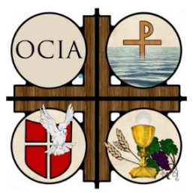
The Order of Christian Initiation of Adults (OCIA)
The Inquiry phase of OCIA has begun. Deacon Tim Crooker and Barb Yoder continue to meet with those inquiring about the Catholic faith on Monday evenings, 6 p.m. at St. James campus.

We welcome all who are seeking to join us during this OCIA period of Inquiry. Please pray for those who are considering the Catholic faith.

OCIA Volunteers Needed
- We are seeking volunteers to prepare or purchase refreshments and deliver them to either the St. James or St. Bernard church office for our Monday night meetings. Call for details and to volunteer.

- We are also seeking volunteers, who would consider walking alongside our catechumen (those to be baptized) on their faith journey as sponsors/godparents.

If you are interested in helping with either of these service opportunities, please contact Barb Yoder or Tim Crooker to learn more.

Catholic Young Adult Gatherings
QUEEN CITY CATHOLIC: St. Peter in Chains Basilica, upcoming Sacramental Hub dates: October 21, November 4 & 18, Dec 2 & 16, Jan 13 & 27, Feb 10 & 24, March 24, Apr 7 & 21, May 19.
WESTSIDE CATHOLIC: Nov 6, 14, 22 & 26, see below for topics and locations.

Feeding the Hungry Community Service Project
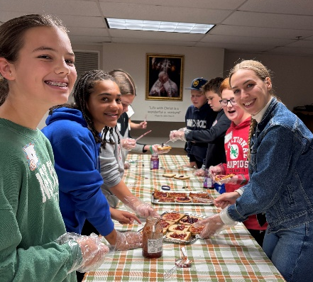
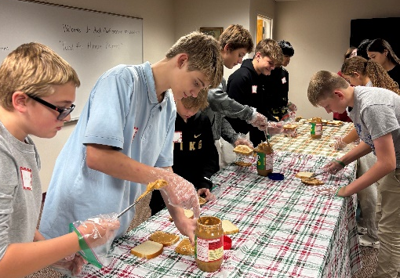
Teens from all three MQH schools and all 4 parishes worked together in service to the community. It was a wonderful evening of friendship and service with 30 who participated in supplying sandwiches for “Our Daily Bread” in Over the Rhine area. Thank you to all parents and parishioners for donating peanut butter, jelly, bread, and Ziploc bags. You are truly a blessing to our community!
